# Narrative Tool Document

Dominic McNeill – 102061800

Updated for version – 1.0.0

# Table of Contents:

Contents

Narrative Tool Document 1

Table of Contents: 2

Downloading and installing the tool: 3

Installing inside Unity: 4

Using the tool to create a dialog asset: 5

Navigation: 6

Creating a node: 7

Breakdown of the node: (PUT UNIVERSE IMAGESSSS) 8

Option display field: 8

Input and Output: 9

Dialog box: 12

Start node: 13

Tool bar: 14

Saving: 14

Note: 15

Loading: 16

Clear: 17

Scriptable asset: 18

# Downloading and installing the tool:

You will need Unity. Ideally, Unity **2023.2**, please use this version as it is the tested version.

Please download the tool from the releases.



Note:

Make sure to extract the zip!



# Installing inside Unity:

Once you have extracted the zip, please copy the folder with the package.json into your packages folder inside the unity project.



Unity should recompile.

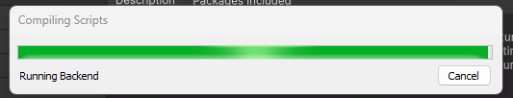

Once complete, you should see the package in the package manager.

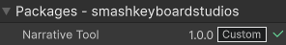

Once you have done that, you are ready to use the asset!

# Using the tool to create a dialog asset:

To start off, lest open the node-based editor.

Click Window > DialogTreeEditor to open the editor.



Once open, you can start working on the dialog.

## Navigation:

You can use middle mouse button to move around the gird.

You can also use scroll wheel to zoom in and out.

There is also drag selection as well.



## Creating a node:

Let’s start by creating a node for our dialog to start.

Right click anywhere inside the dialog tree editor and select Add Dialog Node.



## Breakdown of the node: (PUT UNIVERSE IMAGESSSS)

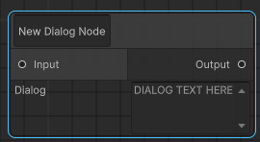

This is a dialog node; this allows you to display text from an option.

### Option display field:

The field in the top left corner is the text to display for the option, examples, yes, no, hello, bye, thank you. It’s up to you what the prompt for the player is.

These options are for what the player’s character says.

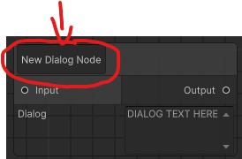

// cans we have image of choices in universe.

### Input and Output:

The input and output nodes allow you to create the dialog flow, you may want to have multiple responses or make the dialog feel more fluid and flexible.

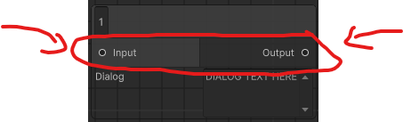

To link a node to another node you just need to drag the output node from one dialog node to the other dialog node’s input.

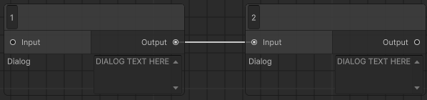

A simple way is to link one to another. This is a linear dialog, no multiple choices, just one choice.



Now, if you want to have multiple choices, you can branch out to multiple nodes.

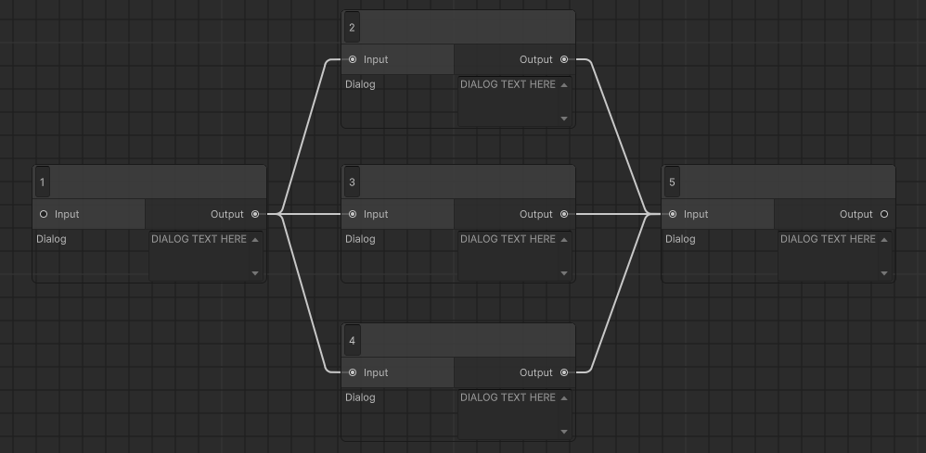

Here shows that the player can pick 3 options. They all will still end on one final node.

This is equivalent to semi-linear dialog.

// universe image.

If you want to end on different dialog options, you can by ending on the branch.

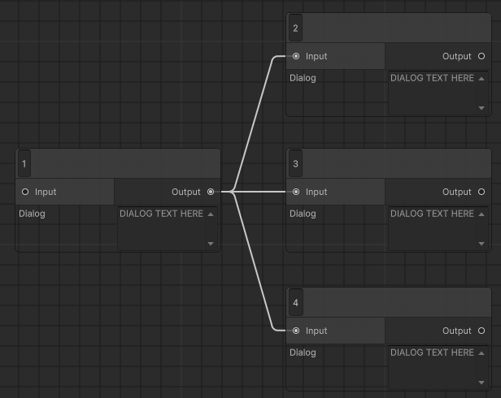

Here the conversation will end on any of these three options.

// universe image.

### Dialog box:

Now, you want to add some actual dialog. To add some dialog, you just need to add text to the box that says, “DIALOG TEXT HERE”.

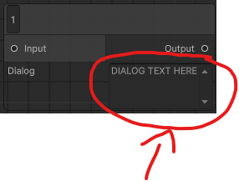

Click inside that box and you can start adding dialog.

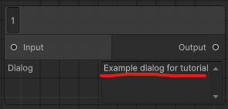

## Start node:

The start node assigns a dialog node as the beginning piece of text.

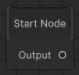

It is required to be linked to the starting dialog node of choice. Otherwise, the program does not know the start node and cannot function properly. To link the start node to a dialog, you just need to drag the start output node to the dialog input.

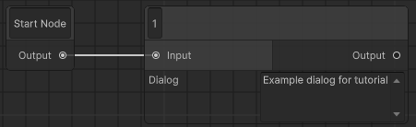

# Tool bar:

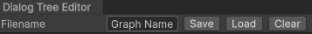

## Saving:

The save button allows you to save the dialog tree as a physical file.



The graph name field is the name for the asset that is generated.



Clicking on the save button will prompt you to save the file in a location using your systems file system.

Important note, you must save inside the asset files otherwise it will reject you.

This creates a scriptable object that you can use to read in scripts.

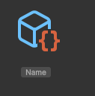

### Note:

If you save the asset, any references to scripts will be lost, so make sure to re add the references.

## Loading:

You can also load the asset to edit it.



You just need to click load and select the dialog tree asset to open it.

(You can also double click the scriptable object or click open on the scriptable object)

## Clear:

# Scriptable asset: